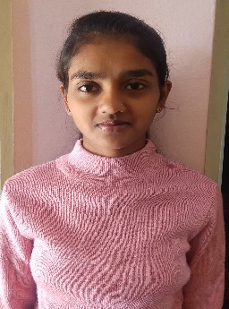**RESUME**

Ramya G M

Mobile: 9980689183

Gmail:ramyagm.24@gmail.com

**CAREER OBJECTIVE:**

To build my career in an organization where I can work passionately and deliver my best efforts for the growth of the organization that provides the opportunity to sharpen my skill intelligence and creativity.

QUALIFICATION

|  |  |  |  |  |
| --- | --- | --- | --- | --- |
| QUALIFICATION | UNIVERSITY | INSTITUTION | YEAR OF PASSING | PERCENTAGE |
| BCA | Tumkur university | Seshadripuram college | pursuing | 1st sem-86.61 |
| 2nd sem-93.23 |
| 3rd sem-83.63 |
| 4th sem-91.84 |
| 5th sem-89.88 |
| PUC | Pre-university | Seshadripuram  Pre-university college | 2019 | 80.6 |
| SSLC | KSEEB | Sri kannika English school | 2017 | 94 |

TECHNICAL SKILLS:

* Programing language: C, C++, PHP, Java
* Web technology: CSS , XML ,HTML
* Data base: My SQL
* Plat form: Visual Studio

**PROJECT:**

Title: Kamadhenu

Kamadhenu project is a Dynamic websites contains the information about the cow produces and E-Shopping of the products of cow produces.

This project is developed by using the platform visual studio. In this Front end designed using HTML ,CSS and back end is designed using PHP , MYSQL.

**PERSONAL STRENGTH:**

* Fast learning skills
* Self-confident
* Efficient team player
* Good communication

**PERSONAL DETAILS:**

**NAME:** Ramya G M

**FATHER NAME:** Mahalingaiah G S

**MOTHER NAME:** Rajasulochana

**DOB:** 24 – 11 – 2000

**GENDER:** Female

**HOBBIES:** NSS Candidate , Sports person , Drawing.

**DECLARATION:**

I hereby declare that all the above information is correct to the best of my knowledge and belief.

Your’s Faithfully

(RAMYA G M)